COMMUNITY ASSISTANCE IN TARAKAN THE URBAN CITY OF NORTH BORNEO PROVINCE

Cici Dwi Kusuma Pasaribu
Government Institute of Home Affairs (IPDN)
cici@lpm.ipdn.ac.id

Rakhmad Kavin
Government Institute of Home Affairs (IPDN)
rakhmadkavin@gmail.com

Abstract

Urban city mentoring is a form of actualizing the Tri Dharma Perguruan Tinggi through the community services activities, social devotion and the development of scientific implementation. Community assistance activities is also a media for IPDNs lecturers to combine between the theories to the government problems with current issues as to enrich the existed theories or to abort the anomaly theory. This service activities are also expected to benefit in particular for Local Government as a form of partnership for the success of government programs, regional development and community building by finding the common solutions to the problem that faced by people in the region. The material of community assistance implemented by IPDNs lecturers team and Praja in Tarakan city derived from research which has valid and benefit for the public. Urban population policy issues, Urban community empowerment and drug eradication. The final result of the urban community assistance is government policy recommendations that could be a reference for Tarakan city in determining the direction of Local Government Policy.

INTRODUCTION

The development of cities in Indonesia has increased very rapidly. This is due to the urbanization happened in cities of Indonesia. Lack of job vacancy up to personal desire of people to try their luck in big city led to the population increased. Proven by the mount of movement from rural to urban area in the year 1970 to 2010 released by the World Bank "the rise of metropolitan regions: Towards inclusive and sustainable regional development in 2015" shows a significant development.
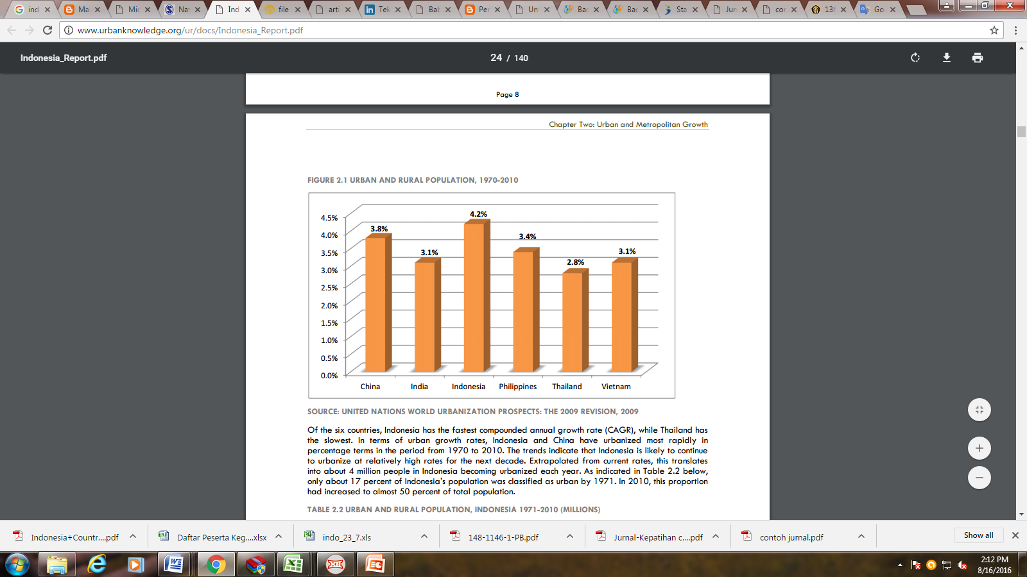

Source: World Bank, 2015

Over the six countries surveyed, Indonesia has the fastest annual growth rate, compared to other countries the condition is nearly equal to China’s growth rate, where Indonesia reached 4.2 % and China 3.8 %.
Considering the tendency above it can be predicted in 2025, about 67.5 percent of Indonesia’s population will live in urban areas. Obviously a lot of negative things will happen. Among other negative impacts caused by the high urbanization revealed by the author Fitri Ramdhani Harahap are as follows :
- The lack of vacant land in urban areas. City population growth is so rapi as the ability of city carrying capacity couldn’t keep it up. Currently, the vacant land in urban areas is very rare, space for shelter, space for the smooth traffic and the parking lot has been very minimal. In fact, the land for greend open space was no longer exists. Vacant land in urban areas has been widely used by the urban as residential, commercial and both legal, illegal industrial. The buildings constructed for trading and industry generally owned by the newcomers. Besides, the homeless urban used an empty land as their illegal settlement. This led to increase the vacant land in urban areas.
- Adding pollution in urban areas. People who do good in urbanization with the aim to find a job or education generally have a vehicle. The increasing number of two-wheeled and four-wheeled in the city caused many variety of pollution such as air pollution and noise. The ecology is no longer balance as if to maintain the harmony of urban environment. Most of Indonesia’s cities experienced pollution problem as the result of urbanization, both by the mount of vehicles as well as the growing industries.
- The cause of natural disasters. The unemployed urban who usually lived on vacant land in the downtown or along the riverside area, build illegal housing and conduct trading activities. This certainly make the land worth as watershed before can no longer soak up the rainwater and flood came by. The riverside as watershed area could not accomodate rainwater anymore.
- The economic and socially pollution. The movement of villagers from rural to the city do not matter if they have certain skills that are needed in the city. However, the fact is many of those who came did not have the skills except farming. It is difficult for them to get decent job. They were forced to work as a day laborer, night guard, housemaid, pedicab driver or street vendors and other similar jobs. This finally increase the unemployment number in the city, to fulfill the needs they will start to commit crimes such as stealing and even killing. There are also some of them failed to get a job become unemployed, homeless and prostitutes.
- The cause of traffic jams. The density of population in the city causing traffic jams everywhere, plus a growing urbanization. The urban build illegal housing around the streets and most of them own motorcycle that add the volume of vehicles on every street in the city.
- Damaging the urban planning. In developing countries, the cities are not ready to provide adequate residential for the entire population. Moreover, migrants are the poor who can not afford to build or buy a decent housing for themselves. Consequently arising in slum and squatter housing on government lands.

In the context of regional government, urbanization tendency is also happening in Tarakan which is the capital of North Borneo province and the 17th richest city in Indonesia has a comprehensive dynamics urban problems. To see the problem exists in Tarakan, Community Service Institution of IPDN held an urban community assistance program in 2015, it was aim to help the Tarakan Local Government finding solutions of the urban problems and also became a leraning material for both praja and IPDNs lectures.

TARAKAN CITY OVERVIEW
Tarakan comes from Tidung language which means layover (Tarak) and dining (Ngakan), as the name it has suggested the place became a haven or place to take a break and do barter between fisherman and the Royal Kingdom of Tidung before the arrival of Dutch Colonial.
Tarakan has a strategic position for North Borneo province, namely as the driver of growth in the northern region of Borneo and a second gate to North Borneo province after Balikpapan, in adddition as a transit trading city for Indonesia, Malaysia and Philippines. Thus, in national scale, Tarakan is one of municipalities in North Borneo, geographically as an archipelago consists of Tarakan island and Sadau island with the maritime boundary are Makassar sea and South China sea, country border with Malaysia, Tarakan city is Indonesian Archipelagic Sea Lanes (ALKI) II.
As such geographical condition make Tarakan city as a transit route for trading and transport which connected to a few strategic areas. The position and it’s strategic location impact on the level of development and progress of Tarakan city, and the high social dynamics that occured in Tarakan society generally.
Tarakan city is divided into four districts, namely :
- West Tarakan District
- Center Tarakan District
- East Tarakan District
- North Tarakan District
Tarakan city consists of 4 districts and 20 subdistricts, West Tarakan district and Central Tarakan each consisting of 5 subdistrict, for East Tarakan district has 7 subdistrict and 3 subdistrict for North Tarakan district.

TARAKAN URBAN COMUNITY SERVICE METHOD
Community service activity held on the mandate of Indonesia Constitution article (2) number 20 on Eduacation System stated that “University is obliged to provide education, research and community service”. Community Service Institution of Institute of Public Administration of Home Affair (IPDN) is an implementing element of the Tri Dharma Perguruan Tinggi function in IPDNs environment which implement and coordinate the implementation of community service, social devotion and scientific implementation development also appropriate technology in the context of urban, rural, coastal and border community service.
In implementation rector of IPDN issued a rector decree No. 896.1-336 2015 about the Speaker and Moderator Appointment for Urban Community Service in Tarakan City of North Borneo Province and rector decree No. 411.3-3337 2015 on Escort Appointment for Urban Community Service in Tarakan City of North Borneo Province, with aim to actualize the role of Tri Dharma Perguruan Tinggi.
Community Service activity carried out by community assistance method to help the communities to find “Problem Solving” related to the government issues or themes that had been agreed by the Local Government with IPDN. In Tarakan city the urban community assistance held in two district, West Tarakan district and Central Tarakan district each 2 times by presenting 50 (fifthy) per district consisting villagers and the subdistrict apparatus; local institution in the village; public figures; religious leader; youth leader; community organizations and PKK member to discuss urban population policy issues, urban community empowerment and drug eradication.
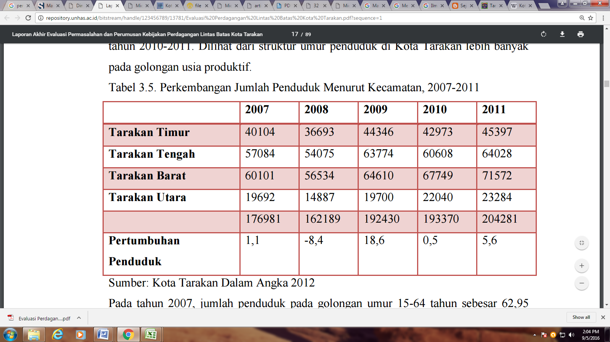
The final result of this urban community assistance is government policy recommendations that could be a reference for the Tarakan city government in determining the direction of local government policy.

TARAKAN URBAN COMMUNITY ASSISTANCE RESULT

Urban Population Policy
Tarakan city government has started to realize that population growth for the last five years was quite high. Statistic data released by BPS in 2012 states that in 2007 the population of Tarakan city reached 176.981 inhabitants then increased to 204.281 in 2011 were distributed to four district in Tarakan city with the largest population was West Tarakan district, followed by Central Tarakan district and the smallest population was North Tarakan district.

Population Growth in Tarakan
by District, in 2007-2011

Source: Tarakan city in figures, 2012

The population growth in Tarakan city also has an impact to employment based on data released by Tarakan city BPS in 2012 belonging to labor force increased from 62.934 in 2017 to 92.800 people in 2012. By the number, over 80 percent absorbed into labor market. Number of working increased from 54 613 people became 86 052 people in 2012. However, there are still over seven thousand people in 2012 who still do not get a job (unemployed), or about 8.26 percent of the workforce.

The Development of Worker, Unemployment, TPAK, TKK, and TPT
In 2007-2012
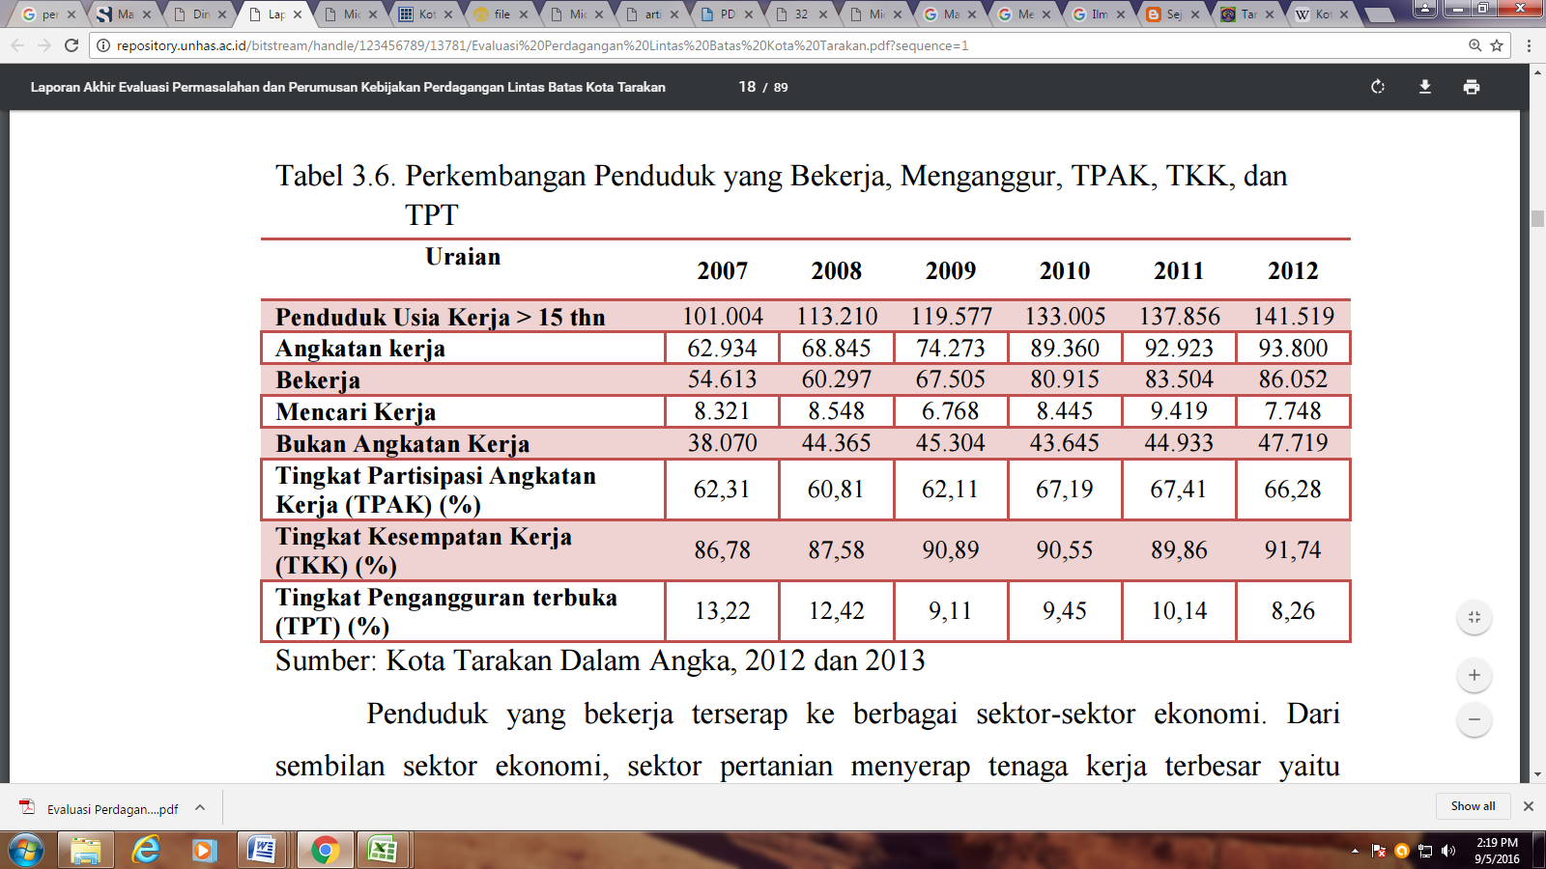

Source: Tarakan city in figures, 2012

Agricultural sector absorbed around 29.41 percent of labor force in 2012. The order for the two large stare the social service sector where the number of workers absorbed as much as 21.30 percent and trading, restaurants and accommodation services amounted 19.18 percent absorb. The sectors absorbing the least are electricity, gas and drinking water.
Seeing the condition of population growth rises above IPDN lectures team for urban community assistance analyze and conclude that the problem of population growth in Tarakan are affected by the migration that difficult to be recorded because of the geographic condition where Tarakan city is the only one in North Borneo province as the gate to Indonesia, so many of the migrants landed on the shore without reporting to the government.
That requires recommendation as the solutions offered in the resolution of these problems are as follows:
- Tarakan city government need to create a policy for migrants who are not capable, under five years local government will do clarification regarding the status of residence to place of origin.
- If a resident is concerned has been five years or longer, and has been married to local community, local government should make remission policies.
- Tarakan local government need to create reporting system 1 x 24 hours for newcomer so coordinated with the RW and sub-district apparatus in writing and visual.
- Tarakan government needs to make a compulsory reporting policy periodically in three months or as the local government wisdom.

Urban Community Empowerment
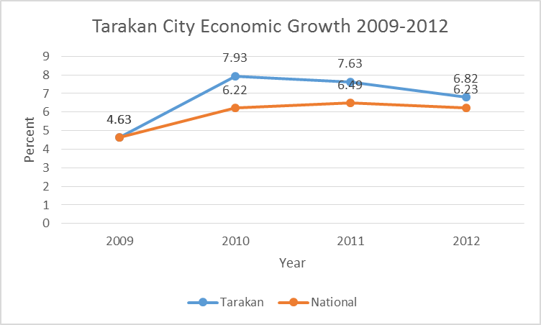
The function of community empowerment generally is to release shackles of poverty and uneducational community. It is expected to enhance the independence of the community to develop themselves to be able to improve their lives. In the years 2009-2011 the economic growth rate is an average of 6.82 percent per year, this figure is far above the national average of 5.89 percent. However, the pace of Tarakan economic growth per year seems to slow through 2012.
During this period, trading sector, hotels and restaurants grew on average 7.7 percent per year, transportation and telecommunications sector (8.3 percent), and financial sector grew on average (8.2 percent) per year, this condition shows that the economic growth from the supply side are driven by these three sectors. Despite the agricultural sector was a big enough contributors for the GDP, the growth rate were relatively low at only on average of 5 percent annually. While the sector that growing slowly were manufacturing and mining each on average 3.6 percent and 4.1 percent. Slowing economic growth during 2012 due to all business field sectors except manufacturing and building slightly increased compared to the previous year.
In 2009, the agricultural sub-sectors that contribute most to the agricultural sector is the fisheries sector with a value of Rp 456.8 billion. This sub-sector increased to Rp 629.9 billion in 2011. The increase in fishery production is supported by a mount of fishery processing industry. In 2012, the largest fishery production volume contributed by catching fish as much as 4136.50 tons, the pond as much as 668.50 and the pool as much as 21.30 tons. The total number of fishery production as much as 4826.30 tons. The largest production of processed product was salted fish as much as 1054.14 tons in total of 2171.42 ton. Meanwhile other sector has not significantly contributed to Tarakan GDP.

GDP Growth Rate in the Field of Business
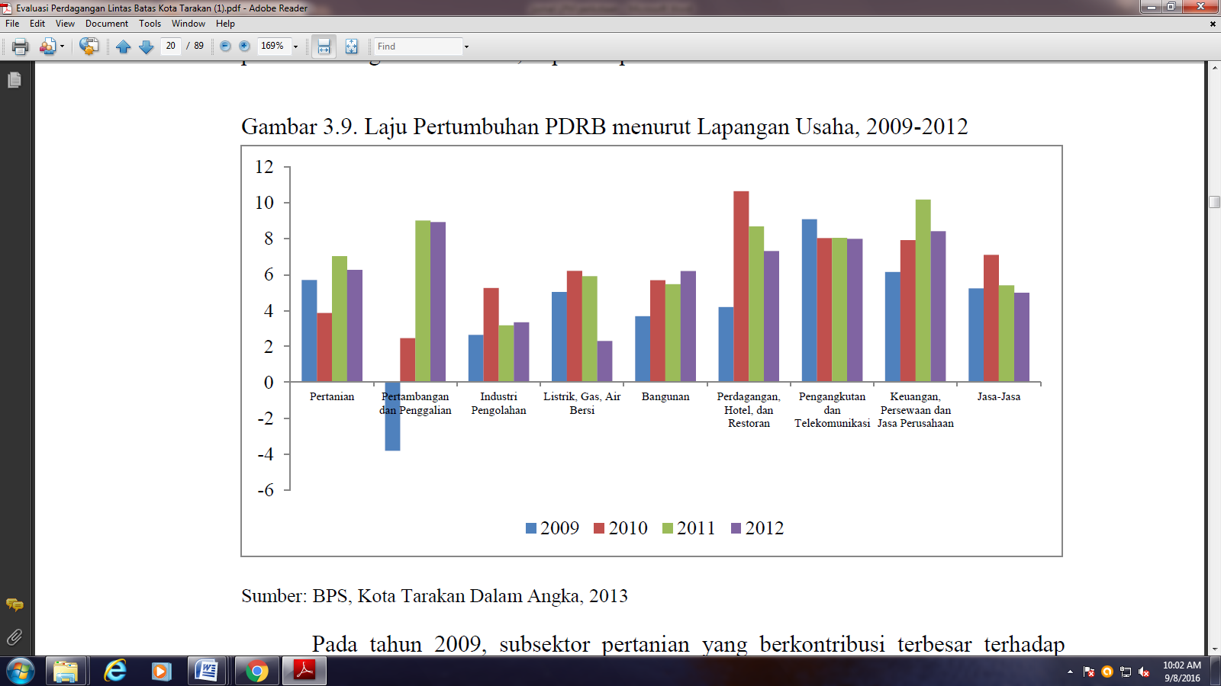
In 2009-2012

Source: Tarakan City BPS report in 2012.

Seeing the economic growth conditions IPDNs Lecture team of urban community assistance in Tarakan 2015 discussed and analyze the community conditions, it can be seen that the capacity of community’s skill are still low, so the community empowerment program have not been able to run effectively, as seen on the lack of SMEs condition and people have not been able to develop potential resources of the community empowerment institute (LPM) in managing the community empowerment organization groups plus the limited budget for community empowerment activities and youth organizations because of the difficulty to allocate the funds for community development activities.
That requires recommendation as the solutions for the resolution of these issues are as follows:
- The local government needs to make an assessment to the role and function optimization of LPMK in supporting the sub-district development.
- Based on the study above local government could adjust the operational funding requirements to support the smoothness of LPMK activities.
- It takes activities synchronization between related agency (SKPD) with community capacity enhancement through LPMK or directly to the public

Drug Eradication
Drug problems are serious issue to be “Homework” for the government and the law enforcer in Tarakan because geographically close to Malaysia. Based on the report of Reskoba Polres Head Unit Inspector Michael Hasugian to Radar Tarakan in 2013 revealed 77 cases with 132 suspects, then in 2014 jumped to 94 cases with 177 suspects and from January to March as many as 27 cases have been recorded with 52 suspects. In 2016, Tarakan Satreskoba Polres board again thwart drug trafficking on Thursday, January 28, catches a drug dealer types of methamphetamine totaling 2.6 kilograms valued at 3.2 billion rupiah.
Based on the analysis of IPDN urban community assistance team in Tarakan 2015 conclude that drug issues caused by Tarakan as a transit area for drug dealer to drug entrance gate. The traffickers used a fisherman as a drug courier to the land. Then distributed to the users in Tarakan city or to another region with assuming user and dealer have been convicted of rehabilitation nearly 70% of children in school age.
It needs recommendation as solutions of resolution to the problems are as follows:
- Optimizing the role of Tarakan BNN supported by the related apparatus in prevention aspects and prosecution.
- Tarakan Mayor Instruction for drug eradication, may be intregrated with vertical institution through the drug eradication task force establishment in every sub-district, school and college.
- Tarakan city government should socialize the danger to the fishermen and seaweed farmer.
- Tarakan city government need to do monitoring and security tracking at 60 points prone to drug.
- Tarakan city government needs to socialize the danger of drug regularly.
- Adding a religious local content in student curriculum by instilling the local value.
- City government needs to prepare budget to carry out a routine inpestion for students on regular basis.
- Tarakan city government needs to seek opportunities for cooperation trough the BNN Center or Private for Rehabilitation construction

CONCLUSION

The urban community assistance result in Tarakan shows an urban complexity issues should be addressed quickly through preventive policies, people live in urban areas also have complex problem and continue to grow with the development of the urban itself. As with other urban areas, Central Tarakan district and West Tarakan district also face various problem; limited of facilities and infrastructure; people’s income; education; environment; accessibility; drugs; etc. Community Service activities carried out by LPM IPDN for five days, has not been fully able to identify various issues contained in the two districts, but there is an attempt manimally to reveal the a small part of the issue that have been benefical for the community, especially in institutional weakness (lack of operational funding agencies in the village community empowernment) and needs thought and ideas, and breakthrough as alternative solutions that can be recommended to the parties concerned to follow up and future activities.

REFERENCES

Books
Arif Kholiq, 2008, Pemberdayaan Masyarakat Sipil. Pusaka Pesantren: Yogyakarta
Direktorat Jenderal pendidikan TInggi, Buku Panduan Tata Cara Penulisan Artikel Hibah Pengabdian Kepada Masyarakat, Dikti: Jakarta
Edi Suharto, 2010. Membangun Masyarakat, Memberdayakan Rakyat. Refika Aditama:Bandung
Wigyosoebroto Soetandyo, 2005. Dakwah Pemberdayaan masyarakat Paradigma Aksi metodelogi. Pusaka Pesantren: Yogyakarta

Journal
Society Journal, Vol. I, No.1, June 2013, “Dampak Urbanisasi Bagi Perkembangan Kota Di Indonesia” author Fitri Ramdhani Harahap, S.Sos, M.Si

Regulations
Undang-undang Republik Indonesia Nomor 20 Tahun 2003 Tentang Sistem Pendidikan Nasional
UU Nomor 25 Tahun 2004 Tentang Sistem Perencanaan Pembangunan Nasional
Surat Keputusan Rektor Nomor : 896.1- 336 Tahun 2015 Tentang Penunjukan Narasumber Dan Moderator Kegiatan Pengabdian Masyarakat Perkotaan Di Kota Tarakan Provinsi Kalimantan Utara
Surat Keputusan Rektor Nomor : 411.3-3337 Tahun 2015 Tentang Penunjukan Pendamping Kegiatan Pengabdian Masyarakat Perkotaan Di Kota Tarakan Provinsi Kalimantan Utara

Internet
World Bank report “the rise of metropolitan regions: Towards inclusive and sustainable regional development tahun 2015” page 1 http://www.urbanknowledge.org/ur/docs/Indonesia_Report.pdf
Laporan akhir evaluasi permasalahan dan perumusan kebijakan perdagangan lintas batas di Kota
Tarakan 2014, page 17
http://repository.unhas.ac.id/bitstream/handle/123456789/13781/Evaluasi%20Perdagangan%20Lintas%20Batas%20Kota%20Tarakan.pdf?sequence=1
http://tarakankota.go.id/v2/news/2107-penyalahgunaan-meningkat-tarakan-darurat-narkoba/info-kota/ on September 5, 2016
http://rajawalikaltara.com/28/01/2016/ckckckck-pelajar-ketangkap-bawa-sabu-3-kilo-tarakan-darurat-narkoba/ on September 5, 2016

Others
Ermaya Suradinata, Rektor IPDN. Bahan Presentasi pada Pembukaan Pengabdian Masyarakat Perbatasan di Kota Tarakan, Provinsi Kalimantan Utara
Raga Sofian, Walikota Tarakan Bahan Presentasi pada Pembukaan Pengabdian Masyarakat Perbatasan di Kota Tarakan, Provinsi Kalimantan Utara
Laporan Hasil Pengabdian Masyarakat Perbatasan LPM IPDN di Kota Tarakan Tahun 2015.

Urbanization is the movement of people who came from the village to the city , or the movement of people from a small town to a big city who aim to settle or find a job .
World Bank report “the rise of metropolitan regions: Towards inclusive and sustainable regional development tahun 2015” hal 1 http://www.urbanknowledge.org/ur/docs/Indonesia_Report.pdf
Society Journal, Vol. I, No.1, June 2013, “The Urbanization Impacts for City Development in Indonesia” author Fitri Ramdhani Harahap, S.Sos., M.Si
Accessed on Tarakan city government website on September 4, 2016 http://www.tarakankota.go.id/
Accessed at https://id.wikipedia.org/wiki/Kota_Tarakan on September 4th 2016
The final report of evaluation of issues and cross-border trading policy formulation in Tarakan 2014, page 17 http://repository.unhas.ac.id/bitstream/handle/123456789/13781/Evaluasi%20Perdagangan%20Lintas%20Batas%20Kota%20Tarakan.pdf?sequence
Ibid.
Ibid.
Ibid
Ibid
Ibid
Accessed on http://tarakankota.go.id/v2/news/2107-penyalahgunaan-meningkat-tarakan-darurat-narkoba/info-kota/ September 5, 2016
Accessed on http://rajawalikaltara.com/28/01/2016/ckckckck-pelajar-ketangkap-bawa-sabu-3-kilo-tarakan-darurat-narkoba/ September 5, 2016

